Preface

This User Guide explains how to use the system to process clean bankers acceptances. It assumes that you are familiar with the basic principles of trade finance relating to clean bankers acceptances, and with web browsers.

# About Clean Bankers Acceptances

Trade Innovation supports clean bankers acceptances. In Trade Innovation, a clean bankers acceptance transaction is created when your bank does one of the following:

* Accepts a term draft drawn on your bank
* Records the fact that a term draft has already been accepted by the drawn-on bank
* Discounts (purchases) a draft drawn-on another bank, that has already been accepted by the drawn-on bank

The creation of a clean bankers acceptance begins when a customer presents the term draft to your bank for acceptance or discounting.

The term draft becomes a bankers acceptance when the drawn-on bank accepts the draft. Normally the word 'accepted' is stamped on the draft, and the drawn-on bank specifies the maturity date, confirming that payment is to be made on that date. Then the accepted draft becomes a negotiable instrument which can be discounted (purchased) by the accepting bank or another bank, and can subsequently be traded in the money market.

The owner of the clean bankers acceptance is termed the beneficiary. There may be several successive beneficiaries as the acceptance is bought and sold. The party ultimately liable to honour the bankers acceptance is the obligor. If the draft is drawn on another bank, that drawn-on bank is the obligor. If the draft is drawn on your own bank, the obligor is the customer who will eventually pay the draft amount on the maturity date.

In Trade Innovation a clean bankers acceptance refers to a bankers acceptance that is created as a standalone transaction, regardless of whether it would otherwise be known as a clean bankers acceptance (in the sense that it is unrelated to any of your existing trade finance transactions) or as a documentary bankers acceptance (arising out of another trade finance transaction such as a letter of credit). If the acceptance is related to another transaction, such as a letter of credit, the system enables you to record the reference of this related transaction.

Once created, a clean bankers acceptance may be:

* Purchased, or rediscounted - bought by your bank at a discounted price. The bank pays the amount of the acceptance, less a discount and any fee, to the current owner of the acceptance. The system processes this either by discounting the acceptance within the Create event, or by using the Purchase event
* Sold, or rediscounted - sold by your bank as the current owner, at a price further discounted. The system processes this using the Sell event. If the accepted draft is not drawn on your bank, you can choose to mature the acceptance at the time of the sale
* Repurchased - as for a purchase, except that the acceptance is one which the bank has previously sold. This is handled in the same way as for a first purchase, using the Purchase event
* Repaid early - settled, partly or wholly, before the maturity date. The system processes this using the Early Repay event

It is possible that, once a clean bankers acceptance has been created, there will be no more events for that transaction until its maturity. This may occur, for example, if your bank discounts a draft (purchasing it as part of the Create event) and then retains the draft until its maturity.

## Financing Clean Bankers Acceptances

The system uses its financing functionality to handle the discounting, interest calculation, and related processing for clean bankers acceptances.

Whenever a clean bankers acceptance is purchased (discounted), the system automatically creates a financing transaction representing the finance deal that results from the discount. When the clean bankers acceptance is sold (rediscounted), repaid wholly or in part, or matured, that financing transaction is automatically settled. The financing product Finance Clean BA is used for these transactions.

Such financing deals are treated as transactions related to the clean bankers acceptance transaction. They can be viewed by pressing the Cross Ref button on the Master Summary window for the clean bankers acceptance, or from the Master browser. Once created, the financing transaction is updated and processed by the clean bankers acceptance transaction. Events in the financing transaction can be viewed from the clean bankers acceptance as subsidiary events.

See the Financing User Guide – Trade Innovation for details of financing products and financing transactions.

## Maturing Clean Bankers Acceptances

When a clean bankers acceptance is created, the settlement date of the effective draft is defined as the maturity date for the acceptance. However, it is possible to mature the clean bankers acceptance before that maturity date. A clean bankers acceptance can be matured by any of the following:

* A Sell event (see page17), if a draft drawn on your own bank is being sold
* An Early Repay event (see page 20), if a draft drawn on your own bank, and that is currently owned by your own bank, is being repaid in full
* A Mature event (see page 23), when the acceptance is being settled on its due maturity date

1. Maturing a clean bankers acceptance also expires the master. The status of the master is set to EXP on the completion of whichever event causes it to be matured. The normal Expire event is not used for clean bankers acceptances.

## Event Parties in Clean Bankers Acceptances

In every transaction, the system identifies the two main parties with whom your bank has dealings with as the principal party and the non-principal party. The principal party is generally the party who is your customer on the transaction. In clean bankers acceptances, because the ownership of an acceptance can be frequently transferred, the identity of the non-principal party in particular can vary from event to event. The following table therefore identifies the principal and non-principal parties for each event. It also specifies which are the credit and debit parties for funds movements:

|  |  |  |  |  |
| --- | --- | --- | --- | --- |
| Event | Principal | Non-principal | Credit | Debit |
| Create | Obligor | Set to blank if acceptance is discounted. Otherwise, the beneficiary | Beneficiary | Obligor |
| Purchase | Obligor | Set to blank | Seller | Obligor |
| Sell | Obligor | Buyer | Obligor | Buyer |
| Early Repay | Obligor | Set to blank if acceptance is discounted. Otherwise, last known beneficiary | Beneficiary | Obligor |
| Mature | Obligor | Presenter | Presenter | Obligor |

## Using Trade Innovation to Process Clean Bankers Acceptances

The table below list the events covered in this Guide, explaining what each event allows you to do. The table lists the names given to events when the system is delivered. Your bank can change these names once the system is installed. Consequently, the names in your version of the system may be different from the ones listed here.

There are two names for each event:

* The full name, which is displayed when you choose a new event
* The short name, which is displayed in the Work in Progress pane of the Master Summary window

This Guide uses the full name of each event, as delivered with the system.

In addition to the events listed in the table, you can also use the functionality described in the Common Facilities User Guide – Trade Innovation when processing transactions in the system.

|  |  |  |
| --- | --- | --- |
| Full Name | Short Name | What it Does |
| Adjust | Adjust | Allows you to make changes to any of the information held for a clean bankers acceptance (see page 28). |
| Advise Maturity | Advise Mat | Allows you to inform the parties in advance that a clean bankers acceptance is being matured on its maturity date (see page 23). |
| Create | Create | Allows you to create a new clean bankers acceptance, and optionally to discount it at the same time. |
| Early Repay | Repay | Allows you to process the obligor's early repayment of a clean bankers acceptance (see page 20). |
| Mature | Mature | Allows you to mature a clean bankers acceptance, manually or automatically, on its maturity date (see page 24). |
| Purchase | Purchase | Allows you to purchase (discount) an existing clean bankers acceptance (see page 14). |
| Reverse Maturity | Reverse | Allows you to reverse the automatically processed maturity of a clean bankers acceptance, if that maturity was inappropriate or contained errors (see page 24). |
| Sell | Sell | Allows you to sell (rediscount) a clean bankers acceptance (see page 17). |

## Using Deal Templates to create Clean Bankers Acceptances

Trade Innovation permits you to create deals (transactions) from templates and/or, if you have the capability ManageDealTemplates assigned, to add, update and delete deal templates.

You can create a new Clean Bankers Acceptance from a template at one of three points:

* From within the TI Dashboard. In the New Master pane, the Create from Template button allows you to select the template to use. You must specify the Team, the Branch and the Product.
* From within the Master Browser window. In the New Master pane, the Create from Template button allows you to select the template to use. You must specify the Team, the Branch and the Product.
* From within a transaction, during the Input step of an event that is creating a new master record. The Create from Template link allows you to select the template to use.

See the Common Facilities Guide – Trade Innovation for further details.

# Creating a Clean Bankers Acceptance

The Create event enables you to enter full details of a new clean bankers acceptance. This means that you can process the acceptance of a term draft drawn on your bank, or you can record for discounting (purchase) purposes the acceptance of a draft that is drawn on another bank, and has already been accepted by that bank. You can choose to purchase (discount) the acceptance as part of the Create event.

To create a new clean bankers acceptance, in the Masters window, select the Team and Behalf of branch and use the drop-down list in the New Masters pane to select 'Clean Bankers Acceptance', then click New. The system creates a Create event at either at a Log step or Input step. Depending on how your system is configured, panes and fields available in log steps can be tailored for each data capture step. See the *SDK - Screen Tailoring Guide* – Trade Innovation for details.

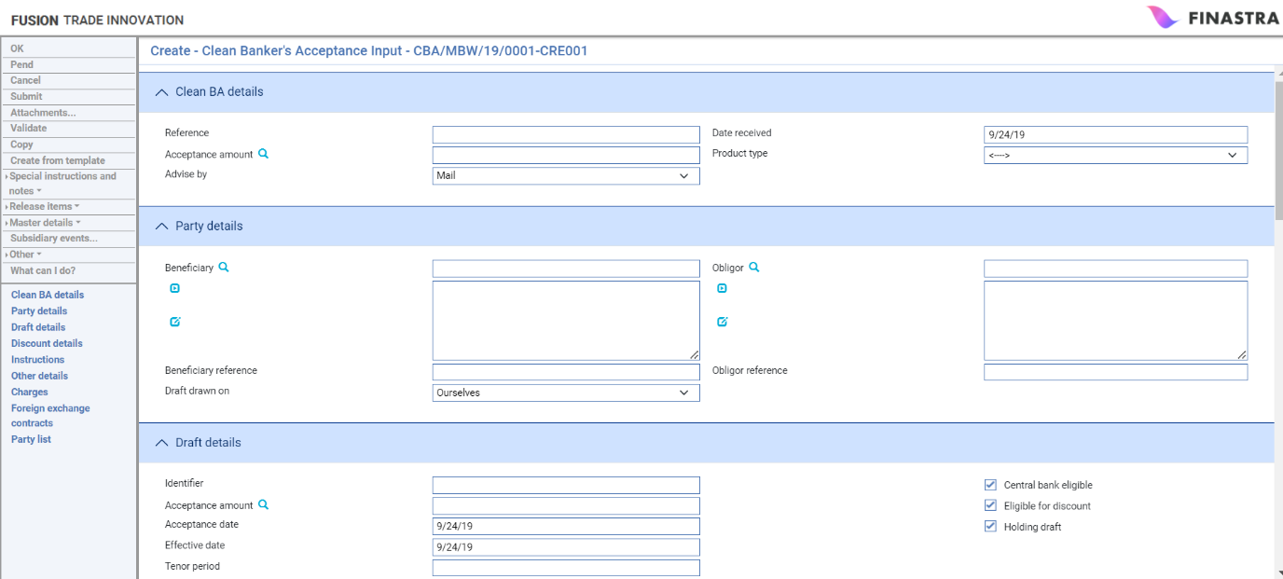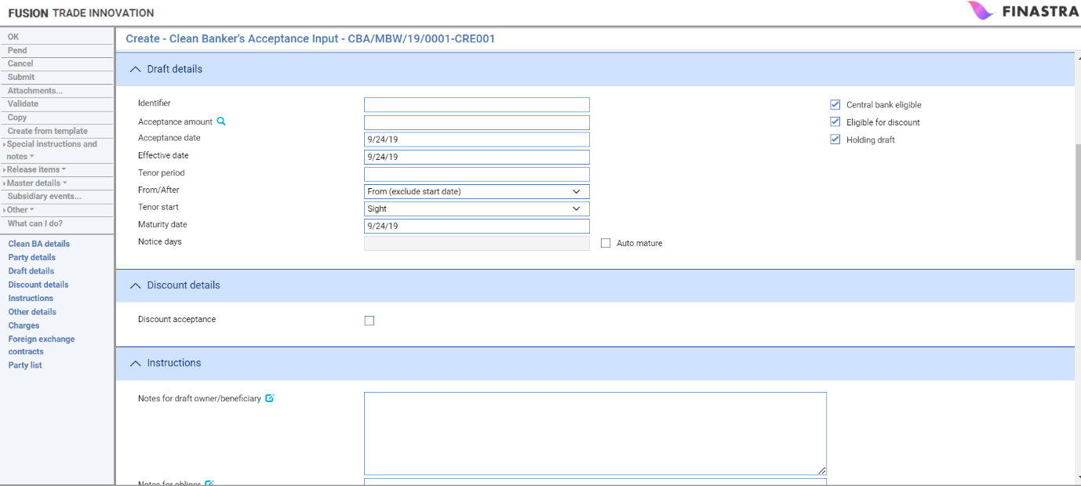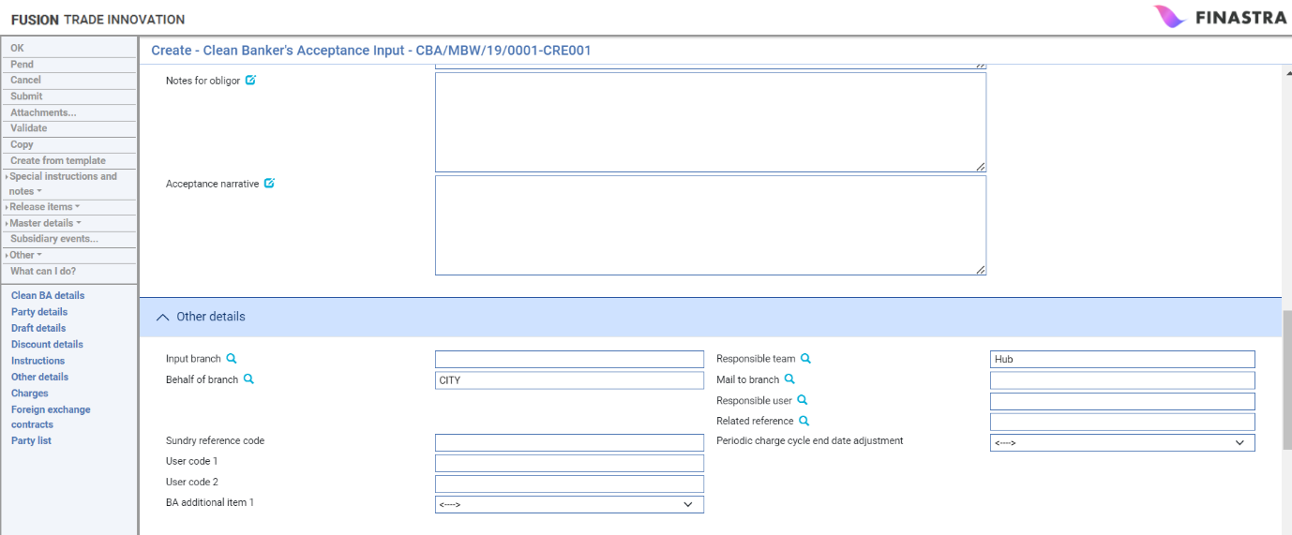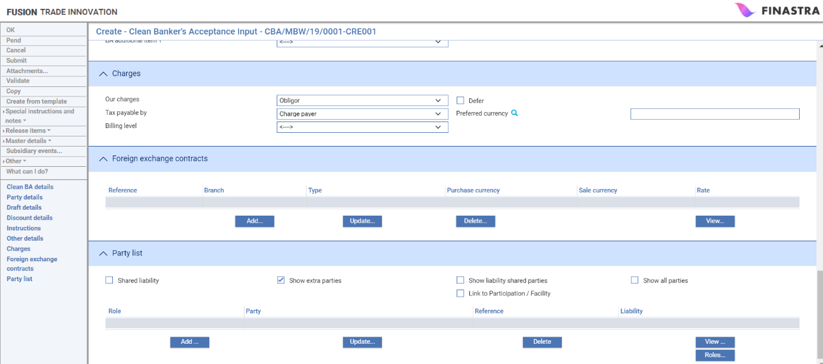

## Clean Bankers Panes

The window used to create a clean bankers acceptance uses the following panes:

* The Clean BA Details pane (see page 7)
* The Party Details pane (see page 8)
* The Draft Details pane (see page 9)
* The Discount Details pane (see page 10)
* The Instructions pane (see page 11)
* The Other Details pane (see page 12)
* The Charges pane (see page 13)
* The FX Contracts pane
* The Party List pane

For instructions on using the FX Contracts pane and the Party List pane see the Common Facilities User Guide – Trade Innovation.

### The Clean BA Details Pane

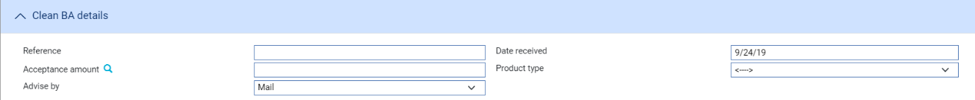

The following table explains what to enter into each of the fields in the Clean BA Details pane:

|  |  |  |
| --- | --- | --- |
|  | Field | What to Enter |
|  | Reference | The reference given to the draft by the obligor. This becomes their reference for the acceptance. |
|  | Date Received | The date that the draft was received for acceptance. Defaults to today's date. |
|  | Acceptance Amount | The total amount of the acceptance. Use the field next to this to define the currency in which you are expressing the amount. |
|  | Product Type | If your bank has set up product types for clean bankers acceptances, select the appropriate one from the drop-down list in this field. Depending on how your system has been configured, this field may be mandatory. |
|  | Advise By | The transmission method to be used to notify the clean bankers acceptance to the beneficiary and the obligor. |

### The Party Details Pane

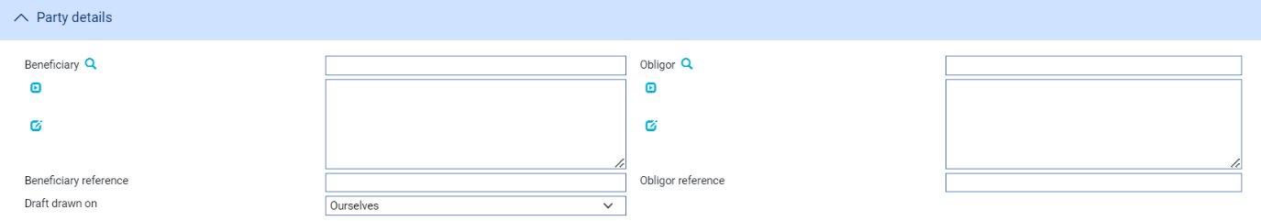

The following table explains what to enter into each of the fields in the Party Details pane:

|  |  |  |
| --- | --- | --- |
|  | Field | What to Enter |
|  | Beneficiary | The current draft owner, or beneficiary, who has presented the draft for acceptance. This party is also known as the non-principal party and the credit party for this event. However, the non-principal party on the acceptance itself is determined when the draft is accepted by your bank. When an acceptance is purchased, this is set to blank to indicate that your bank owns the acceptance. When the acceptance is subsequently sold, the buyer of the acceptance becomes the non-principal party. |
|  | Beneficiary Reference | The reference given to the draft by the beneficiary. This becomes their reference for the acceptance. |
|  | Draft Drawn On | Use the drop-down list in this field to specify who the draft is drawn on. This can be one of:  Ourselves. This is the default, and means that the draft is drawn on the branch of your own bank that inputs the clean bankers acceptance  Own Branch. This means that the draft is drawn on another branch of your own bank  Named Bank. This means that the draft is drawn on the bank specified in the Obligor field |
|  | Own Branch | This field is only displayed if you select 'Own Branch' in the Draft Drawn On field. If displayed, it is mandatory. Use the drop-down list in this field to specify the branch of your own bank on whom the draft is drawn. |
|  | Obligor | The obligor, or ultimate payer of the draft, who is obliged to settle the acceptance on maturity in favour of the current owner of the draft. For a draft drawn on your bank, this is your customer. For drafts drawn on other banks, it is the drawn-on bank.  This party is also known as the principal party and the debit party for the event. |
|  | Obligor Reference | The reference given to the draft by the obligor. This becomes their reference for the acceptance. This is the same as the reference specified in the Reference field in the first pane. |

### The Draft Details Pane

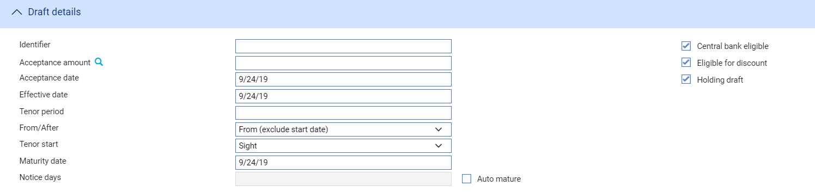he following table explains what to enter into each of the fields in the Draft Details pane:

|  |  |  |
| --- | --- | --- |
|  | Field | What to Enter |
|  | Identifier | A draft identifier. This will have been specified by the drawer of the draft. |
|  | Acceptance Amount | The total amount of the acceptance. This field displays the same value that you entered at the first input window. If you alter the value here, it is also changed in the first pane. |
|  | Acceptance Date | The date when the draft is accepted by your bank, or is recorded as being accepted by the drawn-on bank. This defaults to today's date, and cannot be later. |
|  | Effective Date | This date is used as the base date from which the maturity date is calculated. It defaults to the Acceptance Date, but you can change it. |
|  | Tenor Period/ From/After/Tenor Start | Use the Tenor and Period fields to define the period (as, for example, 1 month or 10 days), then use the From/After and Tenor Start fields to define the date and how the period defined is to be applied to it to arrive at the payment due date. If the tenor is 'from', then the system calculates the tenor as starting on the day of the event; if it is 'after', the system calculates the tenor as starting on the day after the event. |
|  | Maturity Date | The settlement date for the draft. This is calculated from the Effective Date using the tenor information. |
|  | Notice Days | This field is displayed only if 'Auto Mature' is checked.  If Notice Days is set to any value other than zero, an Advise Maturity event is entered into the system’s diary for that number of business days before the acceptance's maturity date. This event enables you to enter the maturity details and to inform the parties of the forthcoming maturity of the acceptance. The Maturity event is also entered into the system’s diary to occur on the maturity date.  If Notice Days is set to zero, the Maturity event is entered into the system’s diary to occur on the maturity date, and the Advise Maturity event is not used.  See the Common Facilities User Guide – Trade Innovation for diary events. |
|  | Central Bank Eligible | Whether the acceptance is eligible for central bank re-discounting because the central bank encourages a secondary market for this type of acceptance. By default this field is checked, indicating that the acceptance is eligible. |
|  | Eligible for Discount | Whether the acceptance is suitable for discounting - that is, eligible to be purchased - by your bank. By default this field is checked, indicating that the acceptance is eligible. |
|  | Holding Draft | Whether your bank is holding the accepted draft on behalf the beneficiary. By default this field is checked, indicating that the bank holds the draft. If unchecked, the draft is assumed to be returned to the beneficiary or presenter once accepted. |
|  | Auto Mature | If this field is checked, the maturity for the acceptance can be automatically processed. By default, this is blank, indicating that maturity is not processed automatically.  Normally you would only check this field if your bank is holding the draft, and the beneficiary's settlement instructions are known. |

### The Discount Details Pane

he Discount Details pane is used if you discount (purchase) the acceptance. In such a case, the Create event automatically creates a financing transaction, representing the finance deal resulting from the discount, which will subsequently be maintained solely from this clean bankers acceptance master.

When you check the Discount Acceptance field, the system automatically displays additional fields.

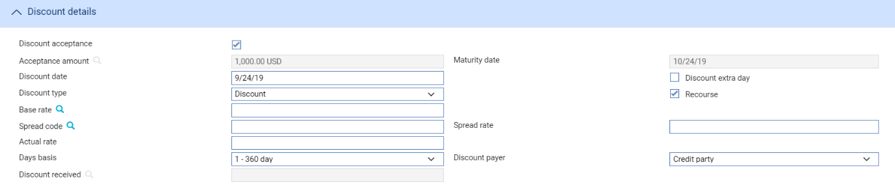These fields allow you to enter details of the purchase (discount) of the acceptance. Acceptance and discounting of the draft are then processed together in this Create event. This causes the Holding Draft field to be automatically checked, as your bank is now purchasing, and therefore holds, the acceptance.

If you do not check this field, you can subsequently process the discounting of the acceptance separately, using the Purchase event (see page 14).

The following table explains what to enter into each of the fields in the Discount Details pane:

|  | Field | What to Enter |
| --- | --- | --- |
|  | Acceptance Amount | The total amount of the acceptance, as already specified. You cannot alter that amount here. Note that the whole amount must be discounted.  The discount currency is the same as the draft currency. If the discounted payment needs to be made in a currency different to that of the draft, you can create a separate FX deal at the settlement level. See the Common Facilities User Guide – Trade Innovation for further details. |
|  | Maturity Date | The settlement date for the draft, as already specified at this window. This also represents the settlement date of the discount. You cannot alter that date in this field. |
|  | Discount Date | The date the discounted payment is to be made. The system uses today's date as a default. |
|  | Discount Type | Specify either Discount or Discount to Yield. This determines which formula is used to calculate the discount. |
|  | Discount Extra Day | Check this field to allow one extra day's interest to be included in addition to the term of the new discount interest. |
|  | Recourse | Leave this field checked if the discount is with recourse. |
|  | Base Rate | Select a base rate from the browser in this field for calculating the discount. |
|  | Spread Code and Rate | Either select a spread code from the browser in this field, or enter a value in the Spread Rate field. The spread is then added to the base rate. |
|  | Actual Rate | Either enter an actual rate here, or enter values in the Base Rate and Spread Code and Rate fields. The system then calculates and displays the actual rate used to calculate the discount. |
|  | Days Basis | The days basis to be used to calculate the interest. A list of valid values is given in the Common Facilities User Guide – Trade Innovation. |
|  | Discount Payer | Indicates whether the credit or debit party is to pay the discount. This defaults to the credit party; that is, the beneficiary. |
|  | Discount Received | The system calculates the discount received, using the rates and other discount information entered in these fields, and displays it here. |

### The Instructions Pane

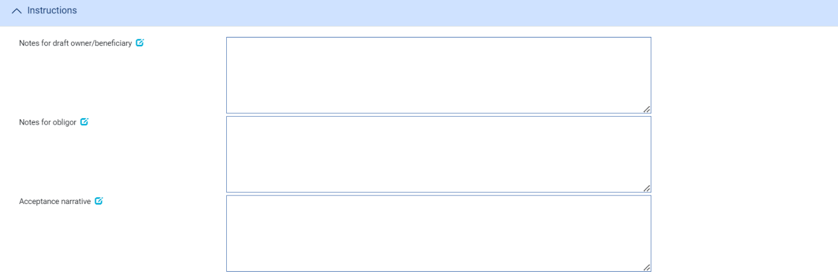

The following table explains what to enter into the fields in the Instructions pane:

|  |  |
| --- | --- |
| Field | What to Enter |
| Notes for Beneficiary | Any narrative text for the beneficiary. |
| Notes for Obligor | Any narrative text for the obligor. |
| Acceptance Narrative | Any text relating to the acceptance itself, especially:  Details of the underlying transaction which gave rise to the acceptance  Details of any collateral, if applicable, can be entered for information only |

### The Other Details Pane

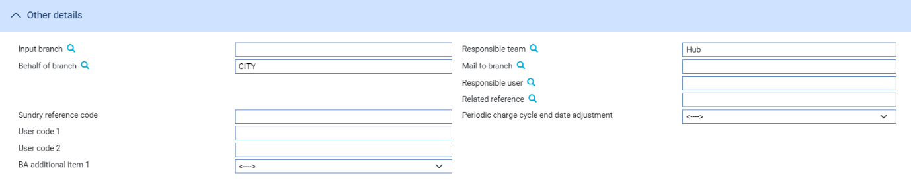

The following table explains what to enter into the fields in the Other Details pane. This pane may also contain fields defined by your bank:

|  | Field | What to Enter |
| --- | --- | --- |
|  | Input Branch | The input branch for the transaction. The input branch is set from either :   * the accounting branch from the user’s team, or * the transaction branch for user if the user has a default transaction branch or is locked to a specific branch, or * a branch associated with the user where the user can enter transactions for several branches for a team |
|  | Behalf Of Branch | The behalf of branch for the transaction as entered by the user or set from the incoming SWIFT or gateway message. The behalf of branch determines the parameter sets that are to be used to generate charges, documents, postings, etc. during transaction processing. The branch can be changed to any other branch within the same main banking entity that shares the same parameter sets. |
|  | Sundry Ref Code /User Code 1/ User Code 2 | You may use these fields to enter values for analysis purposes. Your bank will have devised its own system for using these fields. |
|  | Responsible Team | The team that has overall responsibility for the master e.g. as the contact to resolve any queries or issues regarding the master and associated events. The system defaults the responsible team when creating the transaction as follows:   * Manual – set from team creating the transaction * Gateway – set from the team specified on the incoming message (if present and valid) otherwise to the team to which the transaction is assigned through workflow allocation based on the behalf of branch * SWIFT – set to the team to which the transaction is assigned through workflow allocation based on the behalf of branch   It can be changed, if required, to either the team associated with the primary customer, default team for the product or the user’s current team. |
|  | Mail To Branch | The mail to branch can be set to any branch within the main banking entity of the behalf of branch. |
|  | Responsible User | A user that has responsibility for the master e.g. as the contact to resolve any queries or issues regarding the master and associated events. This can be any user assigned to the responsible team. |
|  | Related Reference | You can specify any other transaction to which this letter of credit is related. This may already have been done when the master record was created. You can use the browser to select from possible references to include. |
|  | Periodic Charge Cycle End Date Adjustment | Select what happens when a periodic charge cycle end date falls on a non-business/working day. See the *System Tailoring User Guide – Trade Innovation* for more information. |

### The Charges Pane

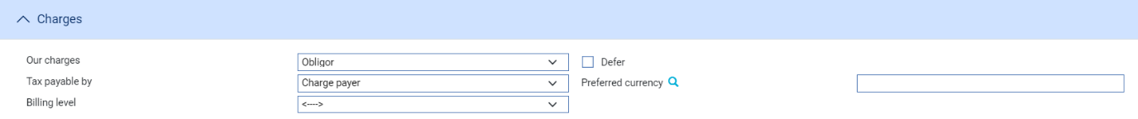

The following table explains what to enter into the fields in the Charges pane:

| Field | What to Enter |
| --- | --- |
| Our Charges | Check either Obligor or Beneficiary to indicate which party pays your bank's charges. The default is Obligor.  If you select Beneficiary here, it implies that the non-principal party pays charges in subsequent events. |
| Defer | Check this field to allow charges to be deferred until a later date.  Normally this would be checked only if the obligor is to pay the charges, as the non-principal party changes whenever the acceptance is purchased or sold. |
| Tax Payable By | The party liable to pay any tax on charges. This defaults to the Charge Payer. If you select Customer, the obligor is liable to pay tax on charges. |
| Preferred Currency | The currency in which the charges will be collected. Typically, you would set this to your local currency. If you leave this field blank, it defaults to the charge currency specified on the Product Options window for clean bankers acceptances. See the System Tailoring User Guide – Trade Innovation for product options.  If no currency is specified in the product options, the system uses the currency of the acceptance amount. |
| Billing Level | Select whether charges for this cash letter should be billed at customer level, transaction level or product level. |

## The Clean Bankers Acceptance Master Summary Window

Once you have created a clean bankers acceptance, the system will display the basic details of that acceptance using the Master Summary window.

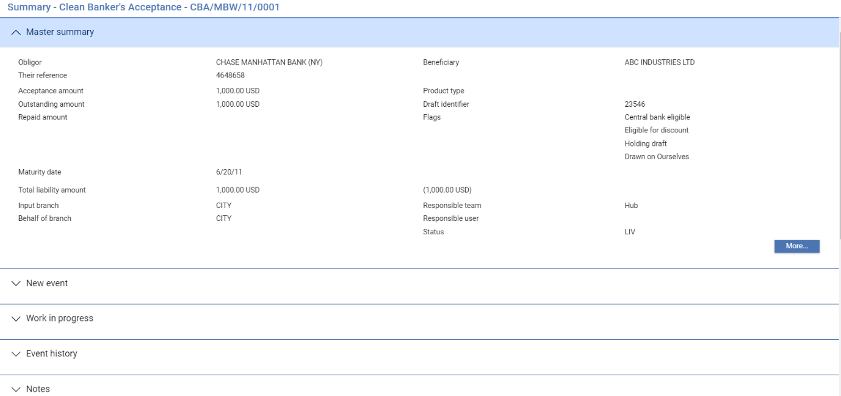

For more information on how the various panes and buttons in this window work see the Common Facilities User Guide – Trade Innovation.

# Purchasing a Clean Bankers Acceptance

A clean bankers acceptance is purchased, or discounted, when the current owner of the acceptance - the beneficiary or seller of the acceptance - asks your bank to buy the acceptance from them. The bank buys the acceptance at a discount, reflecting the remaining term of the draft. This can be done during the Create event that creates the new clean bankers acceptance, or later using a Purchase event (see page 14).

When the bank purchases the acceptance, the seller is paid the full acceptance amount, minus the discount amount (and minus any fees charged by the bank). The discount interest amount can be credited to an unearned discount (suspense) account for subsequent amortisation if required. The obligor acts as the debit party on the discount deal, and their acceptance purchased account is debited with the whole acceptance amount. This means the acceptance liability recorded against the obligor becomes acceptance purchased liability.

The bank now becomes the owner of the acceptance. This is reflected by the non-principal party being set to blank on the acceptance.

When you discount (purchase) a clean bankers acceptance, the Purchase event automatically creates a financing transaction, which will subsequently be maintained solely from this clean bankers acceptance master, representing the finance deal resulting from the discount.

## Repurchasing a Clean Bankers Acceptance

Having purchased an acceptance, your bank may subsequently sell it to an investor and then re-purchase it in the market. Any such re-purchase is also processed using the Purchase event. The subsequent Purchase event assumes the acceptance was previously sold by your bank. Otherwise, you need to create a new clean bankers acceptance.

1. This is a situation different from the owner of the accepted draft presenting the draft to the bank for payment on, or a few days before, the maturity date.

## Entering Details of the Purchase

The Purchase event enables you to enter details of the bank's purchase of an existing clean bankers acceptance. To initiate a Purchase event, in the Master Summary window select 'Purchase' from the Create New Event drop-down list and click Create. The system opens the event at either at a Log step or Input step. Depending on how your system is configured, panes and fields available in log steps can be tailored for each data capture step. See the *SDK - Screen Tailoring Guide* – Trade Innovation for details.

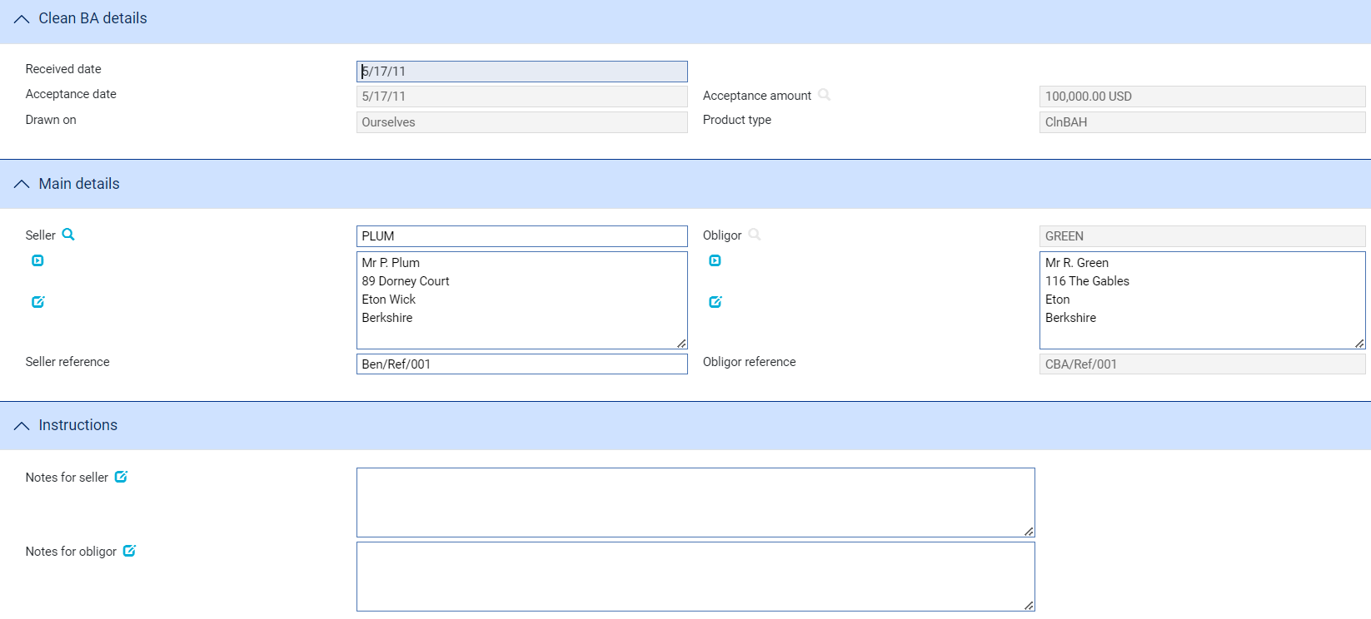

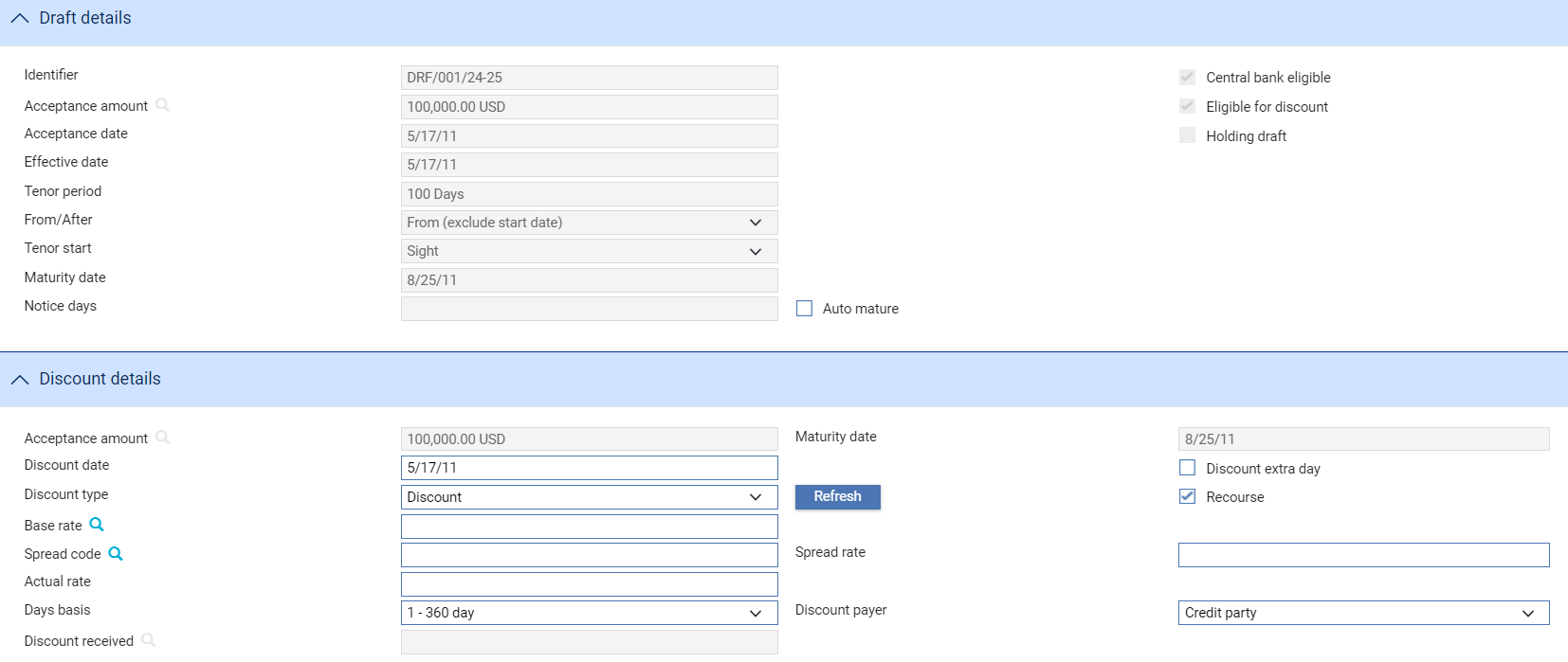

If the acceptance has been defined as not being eligible for discount or as not eligible for central bank rediscounting a warning message will be generated.

Use the Received Date field enter the date the acceptance was received for purchase. This is mandatory information. The field defaults to today's date, and cannot be later than today.

Use the Seller field to identify the current draft owner, who is now selling the draft. This defaults to the party defined as the beneficiary in the Create event, but can be amended because the draft may have been traded since the Create event, and the current seller may not be party who was the beneficiary in that event. This party is the credit party for this event. If known, enter the reference given to the acceptance by the seller. This defaults to the beneficiary's reference from the Create event.

The fields in the Instructions pane allow you to enter any instructions for the seller or the obligor.

The fields in the Draft Details pane display the details of the draft that has been accepted, as they were entered during the Create event. You cannot alter any of these values except for the Auto Mature field. The Holding Draft field is checked regardless of the previous setting, to indicate that the bank is now becoming owner and holder of the acceptance.

The Auto Mature field defaults to the value specified during the Create event, but you can alter it here if required. If this field is checked, the maturity event for the acceptance can be automatically processed. Note that automatic maturity processing includes the settlement of any outstanding discount amount.

The Notice Days field is displayed only if Auto Mature is checked. If it is set to any value other than zero, an Advise Maturity event is entered into the system’s diary for that number of business days before the acceptance's maturity date. This event enables you to enter the maturity details and to inform the parties of the forthcoming maturity of the acceptance. The Maturity event is also entered into the system’s diary to occur on the maturity date. If Notice Days is set to zero, the Maturity event is entered into the system’s diary to occur on the maturity date, and the Advise Maturity event is not used.

The fields in the Discount Details permit you to enter details of the purchase. The following table lists them and explains what to enter into them:

|  |  |  |
| --- | --- | --- |
|  | Field | What to Enter |
|  | Acceptance Amount | The total amount of the acceptance. You cannot alter that amount here. Note that the whole amount must be discounted.  The discount currency is the same as the draft currency. If the discounted payment needs to be made in a currency different to that of the draft, you can create a separate FX deal at the settlement level. See the Common Facilities User Guide – Trade Innovation for further details. |
|  | Maturity Date | The settlement date for the draft, as already specified at this window. This also represents the settlement date of the discount. You cannot alter that date. |
|  | Discount Date | The date the discounted payment is to be made. The system uses today's date as a default. |
|  | Discount Type | Specify either Discount or Discount to Yield. This determines which formula is used to calculate the discount. |
|  | Discount Extra Day | Check this field to allow one extra day's interest to be included in addition to the term of the new discount interest. |
|  | Recourse | Check this field if the discount is with recourse. By default, this is blank. |
|  | Base Rate | Select a base rate from the browser in this field for calculating the discount. |
|  | Spread Code/Spread Rate | Either select a spread code from the browser in this field, or enter a value in the Spread Rate field. The spread is then added to the base rate. |
|  | Actual Rate | Either enter an actual rate here, or enter values in the Base Rate and Spread Code and Rate fields. The system then calculates and displays the actual rate used to calculate the discount. |
|  | Days Basis | The days basis to be used to calculate the interest. A list of valid values is given in the Common Facilities User Guide – Trade Innovation. |
|  | Discount Payer | Indicates whether the credit party (the seller) or the debit party (the obligor) is to pay the discount interest. This defaults to the credit party, that is, the seller. |
|  | Discount Received | The system calculates the discount received, using the rates and other discount information entered in these fields, and displays it here. |

# Selling a Clean Bankers Acceptance

A clean bankers acceptance is sold, or re-discounted, when your bank is the current owner of the acceptance, and wishes to raise funds, or realise profit, by selling the draft it owns. When a buyer is found, the bank sells, or rediscounts, the acceptance. This is done using the Sell event.

The buyer pays the acceptance amount, less the discount interest amount paid by which your bank reduces the selling price. Your bank's fees may be added to the price paid, or may be allowed for in your bank's setting of the discount rate. This effectively allows your bank to mature the discount deal early using the proceeds of the sale.

The acceptance amount received from the buyer is used to repay the obligor's acceptance purchased. The discount interest amount can be paid to the buyer from your profit and loss account which receives the outstanding unearned discount amount (that is, the original discount interest amount less the amount amortised to the date of this sale).

The purchased acceptance liability is cleared. If the draft is drawn on your own bank, the acceptance liability is recorded.

Your bank has made a profit or a loss, amounting to the difference between the outstanding unearned discount amount and the discount interest paid.

The clean bankers acceptance master is kept open if the discounted draft is drawn on your bank, as your bank still expects to settle the acceptance at maturity. If it is not, the acceptance can be expired and made ready for book-off, as your bank expects to have no further involvement in the acceptance.

When you sell (rediscount) a clean bankers acceptance, the Sell event automatically repays, and expires, the financing transaction that was created when the acceptance was purchased (discounted).

## Entering Details of the Sale

The Sell event enables you to enter details of your bank's sale of an existing clean bankers acceptance, which the bank currently owns. To initiate a Sell event, in the Master Summary window select 'Sell' from the Create New Event drop-down list and click Create. The system opens the event at either at a Log step or Input step. Depending on how your system is configured, panes and fields available in log steps can be tailored for each data capture step. See the *SDK - Screen Tailoring Guide* – Trade Innovation for details.

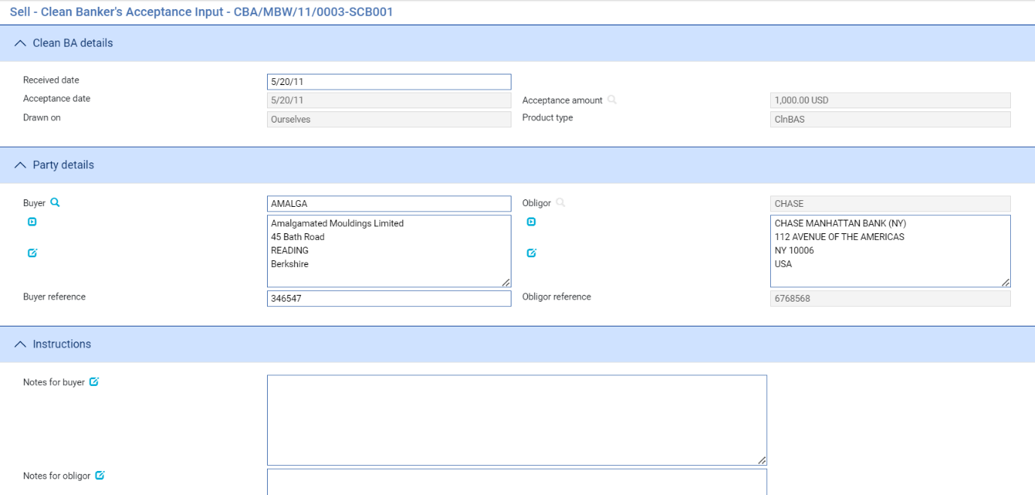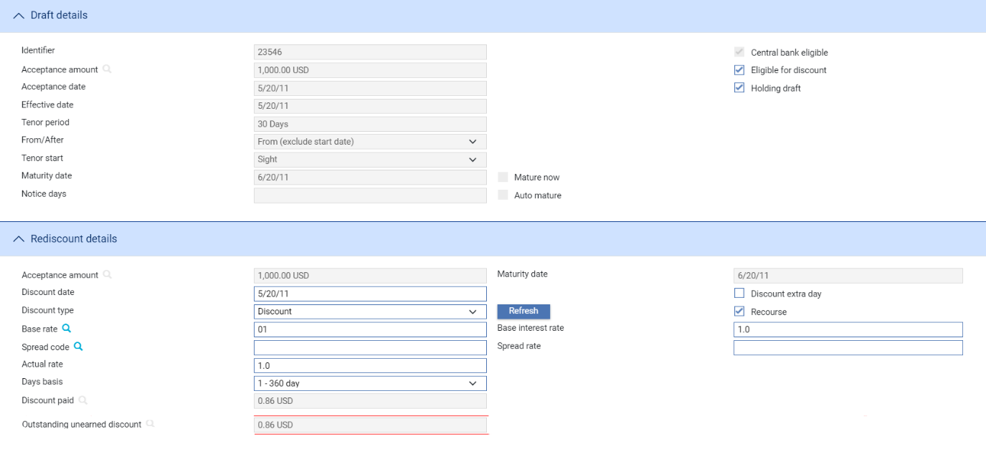

Use the Received Date field to enter the date the sale of the acceptance took place. This defaults to today's date, and cannot be later than today.

Use the Buyer field to identify the buyer of the draft. This party is the debit party in this event and will become known as the non-principal party on the acceptance.

The fields in the Instructions pane allow you to enter any instructions for the buyer or the obligor.

The following table explains what to enter into the remaining input fields in this window:

|  | Field | What to Enter |
| --- | --- | --- |
|  | Eligible for Discount | Indicate whether the acceptance is suitable for discounting - that is, eligible to be purchased. This field defaults to the value specified during the Create event, but you can alter it here if required depending whether the acceptance is eligible for subsequent discounting after it has been sold. |
|  | Holding Draft | Indicate whether your bank is holding the accepted draft on behalf the beneficiary.  By default this field is checked, as your bank owned the acceptance. You need to uncheck this field if the buyer is taking the draft from your bank. Leave it checked if the buyer is leaving the draft with your bank until its maturity. |
|  | Maturity Date | The settlement date for the draft, as already specified at this window. You cannot alter that date in this field. |
|  | Notice Days | The notice period required. |
|  | Mature Now | This field is only displayed if the draft is not drawn on your bank.  If it is displayed, checking this field specifies that the acceptance will be matured on the sale date instead of on the specified maturity date. This means that your bank expects to have no further dealings with this acceptance, and the acceptance can then be expired.   1. Maturity causes the clean bankers acceptance master to expire. The Expire event is not used. By default the Mature Now field is blank, and the maturity date is unchanged. |
|  | Acceptance Amount | The amount of the acceptance being sold (rediscounted).  The currency is the same as the draft currency. If the buyer prefers to pay in a currency different to that of the draft, you can create a separate foreign exchange deal at the settlement level. See the *Common Facilities User Guide* – Trade Innovation for further details. |
|  | Discount Date | The date the rediscounted payment is to be received from the buyer (the rediscount date or sale date). The system uses today's date as a default. This date cannot be later than today, and cannot be earlier than the original discount date specified in the Create event or Purchase event. |
|  | Discount Type | Specify either Discount or Discount to Yield. This determines which formula is used to calculate the discount. |
|  | Discount Extra Day | Check this field to allow one extra day's interest to be included in addition to the term of the new discount interest. |
|  | Recourse | Check this field if the discount is with recourse. By default, this is blank. |
|  | Base Rate | Select a base rate from the browser in this field to calculate the discount. |
|  | Spread Code/ Spread Rate | Either select a spread code from the browser in this field, or enter a value in the Spread Rate field. The spread is then added to the base rate. |
|  | Actual Rate | Either enter an actual rate here, or enter values in the Base Rate and Spread Code and Rate fields. The system then calculates and displays the actual rate used to calculate the discount. |
|  | Days Basis | The days basis to be used to calculate the interest. A list of values is given in the *Common Facilities User Guide* – Trade Innovation*.* |
|  | Discount Paid | The system calculates the discount interest to be paid, using the rates and other information entered in these fields, and displays it here. |
|  | Outstanding Unearned Discount | The system calculates the outstanding unearned discount as the discount interest received less the amount amortised to the sale date, and displays it here. |

# Repaying a Clean Bankers Acceptance Early

Early repayment of a clean bankers acceptance may occur if the obligor wishes to reduce or to clear their acceptance obligation in order to free some or all of their credit line with your bank, or to settle the acceptance using funds raised cheaply elsewhere. Normally this situation only arises with acceptances drawn on your bank. It is handled using an Early Repay event (see page 20).

The obligor repays the amount of the draft, or part of that amount, minus any early repayment discount that may be granted by your bank. When a clean bankers acceptance is repaid early, the Early Repay event automatically repays in whole or in part, and if appropriate expires, the financing transaction that was created when the acceptance was purchased (discounted).

The repayment:

* Is used to repay the discount and clear acceptance purchased liability, if the acceptance was discounted
* Is otherwise credited to a holding suspense account, and used to clear acceptance liability

If the acceptance was discounted, any discount overpayment (the original discount less the amount amortised up to the repayment date) is either realised as your bank's profit or used to fund an early repayment discount if any such discount is granted to the obligor. Early repayment discount can be processed regardless of whether the acceptance has been purchased (discounted) by your bank, and funded for example from your bank's profit or loss account.

1. Any early repayment discount is processed as part of the Early Repay event. Any penalty for early repayment should be set up and processed as a charge on the Early Repay event.

If the draft is drawn on your bank, the clean bankers acceptance master is kept open even if it has been fully repaid, since the acceptance will subsequently be presented to the bank at maturity for payment.

If the draft is not drawn on your bank, and is being repaid in full, you can specify that the master should be matured and expired by selecting the Mature Now flag.

1. A customer who sold a draft to your bank may subsequently wish to settle the discount deal before the maturity date, whilst anticipating payment on the draft at the normal maturity. This is not considered early repayment of the acceptance, and is instead processed using the Sell event, through which the customer buys back the acceptance from your bank.

## Entering Details of the Early Repayment

The Early Repay event enables you to enter details of the obligor's early repayment of a clean bankers acceptance. To initiate an Early Repay event, in the Master Summary window select 'Early Repay' from the Create New Event drop-down list and click Create. The system opens the event at either at a Log step or Input step. Depending on how your system is configured, panes and fields available in log steps can be tailored for each data capture step. See the *SDK - Screen Tailoring Guide* – Trade Innovation for details.

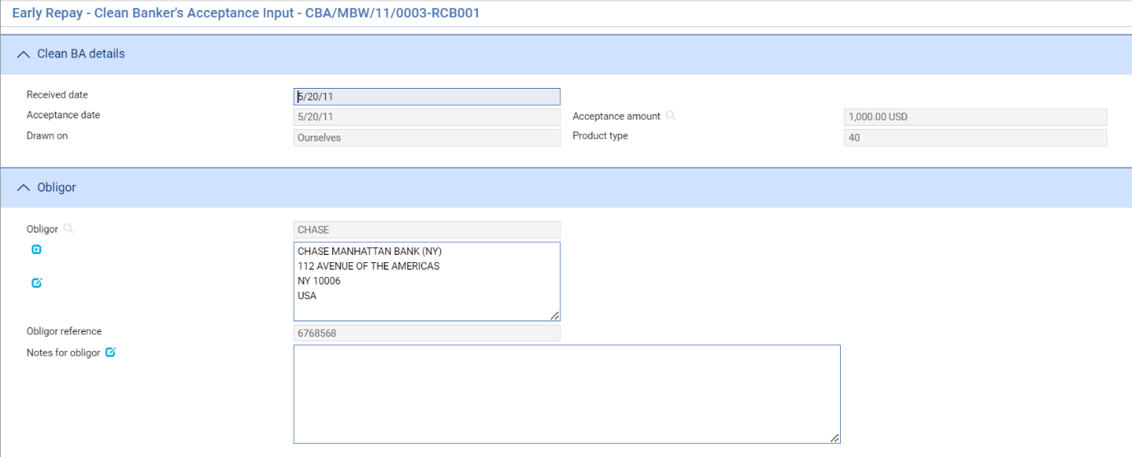

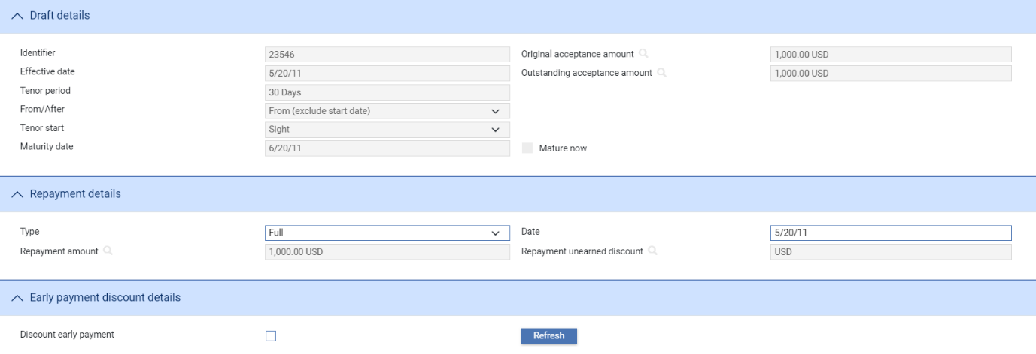

The following table lists the fields enabled for input in this window and explains what to enter into them:

|  | Field | What to Enter |
| --- | --- | --- |
|  | Received Date | The date of the early repayment. This defaults to today's date, and cannot be later than today.  The other fields in this pane default to values entered during the Create event. |
|  | Obligor | These fields display details of the obligor. You cannot alter any of this information. |
|  | Notes for Obligor | Allows you to enter any narrative text for the obligor. |
|  | Mature Now | This field is only displayed if the draft is not drawn on your bank. Checking this field specifies that the acceptance will be matured on the repayment date instead of on the specified maturity date. This is appropriate if the draft is drawn on your bank, the acceptance was purchased (discounted) by your bank, and the acceptance is being repaid in full, as full repayment completely settles the acceptance which your bank owns, and the acceptance can then be expired.  By default the Mature Now field is blank, and the maturity date is unchanged. |
|  |  | Note that maturity causes the clean bankers acceptance to expire. The Expire event is not used. |
|  | Type | Select either 'Full' or 'Partial' to specify whether the acceptance is being repaid completely or only in part. |
|  | Date | The date when the early repayment is to be processed. This defaults to today's date, and cannot be later than today. |
|  | Amount | If you selected 'Full' as the Type of the repayment, this field displays the outstanding amount of the acceptance, and cannot be altered.  If you selected 'Partial', enter the amount of the acceptance being repaid. This must not be greater than the outstanding amount of the acceptance, and must not be zero. |
|  | Repayment Unearned Discount | The system automatically calculates the unearned discount as the discount interest received minus the amount amortised to the repayment date, and displays it here.  This amount relates to discount on the acceptance amount being repaid only. This means that in case of partial repayment, interest on the acceptance amount outstanding after the repayment will continue to be amortised until maturity. |
|  | Discount Early Payment | Check this field if any discount for early repayment is to be given to the obligor and press Refresh. Additional fields are displayed. |
|  |  | Note that any penalty due for early repayment should be treated as a charge for this event. |
|  | Discount Type | Specify either Discount or Discount to Yield. This determines which formula is used to calculate the discount. |
|  | Base Rate | Select a base rate from the browser in this field for calculating the discount. |
|  | Spread Code/ Spread Rate | Either select a spread code from the browser in this field, or enter a value in the Spread Rate field. The spread is then added to the base rate. |
|  | Actual Rate | Either enter an actual rate here, or enter values in the Base Rate and Spread Code and Rate fields. The system then calculates and displays the actual rate used to calculate the discount. |
|  | Days Basis | The days basis to be used to calculate the interest. A list of valid values is given in the Common Facilities User Guide – Trade Innovation. |
|  | Discount Interest Paid | The system calculates the discount interest to be paid, using the rates and other information entered in these fields, and displays it here. |

# Maturing a Clean Bankers Acceptance

A clean bankers acceptance can be matured in any of several ways:

* If a draft that is not drawn on your own bank is being sold, it can be matured as part of the Sell event by checking the Mature Now field
* If a draft drawn on your own bank is being repaid in full, and the acceptance is currently owned by your bank, it can be matured as part of the Early Repay event (see page 20) by checking the Mature Now field
* If neither of these events has occurred before the maturity date, the acceptance is matured, either automatically (see page 23) or manually, using a Mature event (see page 24)

For an acceptance to be matured at its maturity date, its beneficiary (the current owner of the acceptance) presents it to your bank for payment. This presentation normally takes place a few days before the actual maturity date. If the draft is held by your bank, this presentation occurs internally within your bank.

The maturity processing for a clean bankers acceptance enables your bank to:

* Process payment of the full acceptance amount to the beneficiary. This payment is funded by the receipt of the outstanding acceptance payment from the obligor. The amount paid by the obligor takes account of any repayment made early; such repayments are processed using the Early Repay event
* If your bank has purchased the acceptance, to settle and expire the outstanding financing transaction that was created for the purchase (discount) deal, thus clearing the acceptance purchased liability recorded against the obligor. Otherwise, maturity reduces the acceptance liability
* Expire the clean bankers acceptance transaction and make it ready to be booked off

1. Clean bankers acceptances do not use the common Expire event, but are expired when they mature. The status of the master is set to EXP on the completion of the Mature event.

### Automatic Maturity

In some cases, the accepted draft may be held by your bank on behalf of the beneficiary. If so, your bank may wish to specify that the maturity should be automatic, and the beneficiary will not need to present the draft. Your bank may also wish to use automatic maturity for an acceptance which your bank owns after having purchased (discounted) it.

If a clean bankers acceptance is automatically matured, you specify that maturity is to be automatic by checking the Auto Mature field in the Create or Purchase event, the system creates two events in the diary:

* A Mature event
* An Advise Maturity. This is used to advise the beneficiary and the obligor of an acceptance that it is near its maturity. It is scheduled to occur a specified number of days ahead of the maturity date in order to enable this notification to take place. This event is used to record details of the maturity in order to notify the beneficiary and the obligor of the maturity, and to pass those details to the subsequent Mature event. The maturity of the acceptance is actually processed, and the necessary accounting entries generated, by the Mature event

The input window for the Mature event is also available to the Advise Maturity event, and the same details can be entered as for the Mature event.

### Reversing Maturity

When a clean bankers acceptance has been matured automatically, the maturity may occasionally need to be reversed. This can occur:

* If the obligor does not settle the acceptance on the maturity date
* If the obligor returns the acceptance unpaid
* If an automatic maturity event was manually completed, and is discovered to contain errors
* Normally the full reversal is only possible by agreement with the presenter.

You can use the Reverse Maturity event (see page 24) to reverse automatic maturity postings (if you are able to recall funds paid with recourse) and to correspond with the obligor and other parties involved.

The Reverse Maturity event resets the status of the master to LIV, so it can be subsequently matured satisfactorily.

1. Only automatically processed maturity can be reversed.

Alternatively, your bank may choose to process unpaid acceptances entirely outside the system.

## Maturing the Clean Bankers Acceptance on its Maturity Date

The Mature event enables you to mature a clean bankers acceptance, manually or automatically, on its maturity date. To initiate a Mature event, in the Master Summary window select 'Mature' from the Create New Event drop-down list and press Create. The system opens the event at either at a Log step or Input step. Depending on how your system is configured, panes and fields available in log steps can be tailored for each data capture step. See the *SDK - Screen Tailoring Guide* – Trade Innovation for details.

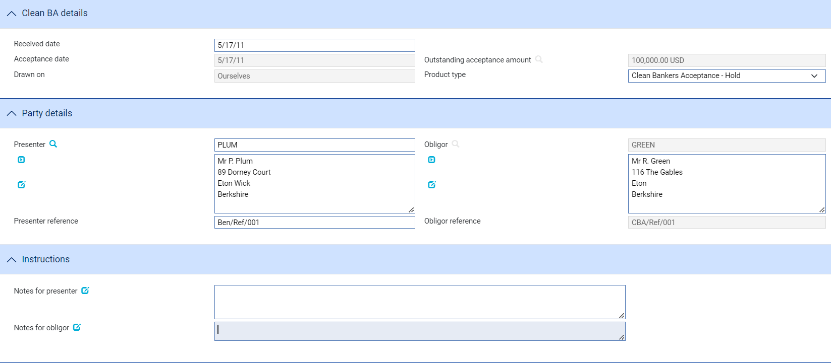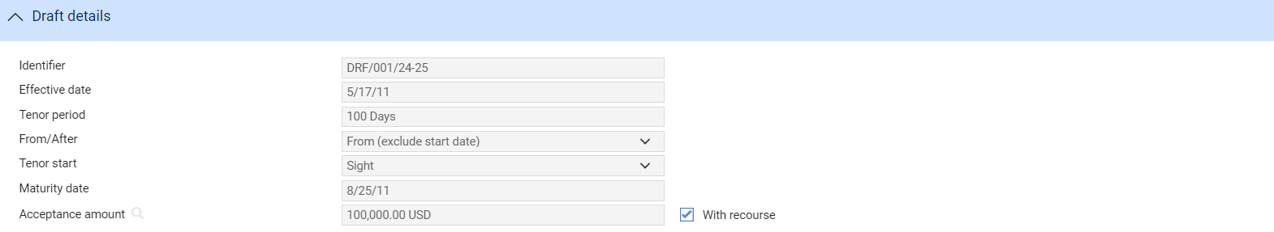

The following table explains what to enter into the fields in this window enabled for input:

|  |  |  |
| --- | --- | --- |
|  | Field | What to Enter |
|  | Received Date | The date the acceptance was presented for payment and maturity processing. If the acceptance was manually presented, this will be the date it was actually handed over. This defaults to today's date, and cannot be later than today.  The other fields in this pane default to values currently held on the master. |
|  | Presenter | The party who actually presented the draft for maturity.  This defaults to the party defined as the beneficiary, but can be amended because the draft may have been traded since it was created.  This party is also the credit party and the non-principal party in this event. |
|  | Presenter's Reference | The reference given to the acceptance by the presenter. This also defaults to the beneficiary's reference. |
|  | Obligor | The obligor.. |
|  | Obligor's Reference | The reference given to the acceptance by the presenter. |
|  | Notes for Presenter | Any narrative text for the presenter. |
|  | Notes for Obligor | Any narrative text for the obligor. |
|  | With Recourse | This field specifies whether the funds paid to the presenter are being paid with recourse or not. By default, this field is checked and payment is made with recourse. |

## Reversing Maturity

The Reverse Maturity event enables you to reverse the automatically processed maturity of a clean bankers acceptance, in cases where that maturity processing subsequently turns out to have been inappropriate or contained errors. To initiate a Reverse Maturity event, in the Master Summary window select 'Reverse Maturity' from the Create New Event drop-down list and press Create. The system opens the event at either at a Log step or Input step. Depending on how your system is configured, panes and fields available in log steps can be tailored for each data capture step. See the *SDK - Screen Tailoring Guide* – Trade Innovation for details.

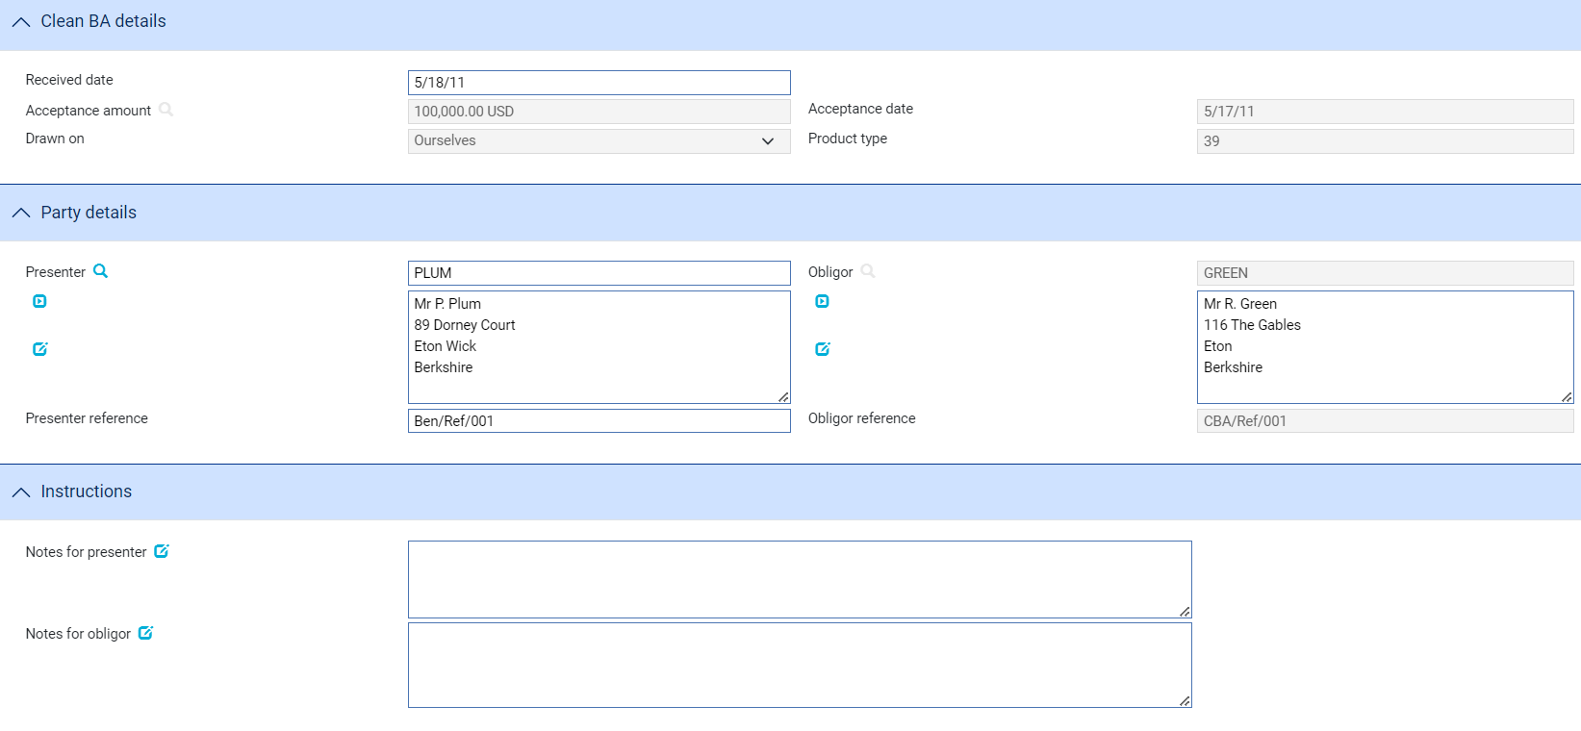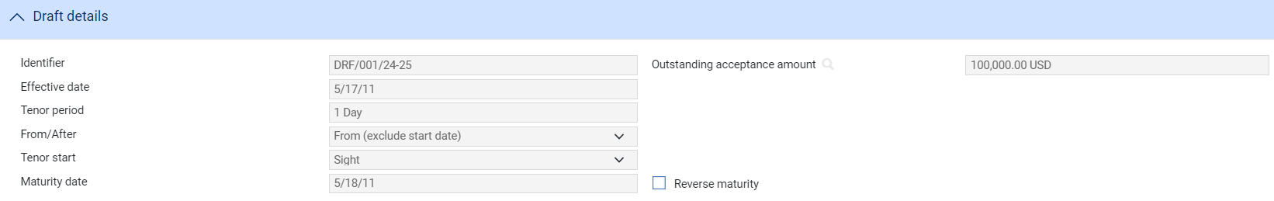

The window shows the details entered during the Mature event (see page 24).

Check the Reverse Maturity field to reverse the maturity event accounting entries and to generate the documents associated with the reversal. By default this field is blank. If it is left blank, reversal postings are not generated and this event can be used principally to inform the parties concerned of the dishonour of the acceptance.

# Making Changes to a Clean Bankers Acceptance

It may be necessary in various different circumstances to make changes to the information already entered for a clean bankers acceptance. In some cases this can best be done using the adjustment event provided. In other cases, however, different events may need to be used to change details of the acceptance.

Details that were entered in the Create event for your bank's internal purposes only, such as the information in the Other Details window, can be changed at any time using the Adjust event (see page 27).

The following table shows examples of possible problems and how they might best be handled:

|  |  |
| --- | --- |
| Problem | Suggested Action |
| The Create event has been completed with incorrect data. The acceptance has not been discounted. | Use the Adjust event to make the necessary changes. The previously recorded acceptance liability will change automatically if it is affected by the changes. |
| The Create event has been completed with incorrect data. The acceptance has been discounted. | Use the Sell event to mature the discount early, after having gained the agreement of the previous beneficiary of the acceptance from whom the acceptance was purchased (discounted).  Then use the Adjust event if necessary to correct the acceptance details. Finally, use the Purchase event to repeat the discounting using the correct data.  This approach ensures that all accounting entries are reversed without requiring the use of the Manual Bookkeeping event. |
| The Purchase event has been completed with incorrect data. | Follow the same procedure as for errors in the Create event when an acceptance has been discounted. |
| The Sell event has been completed with incorrect data. | Use the Purchase event to reverse the sale, after having gained the agreement of the current beneficiary of the acceptance, to whom the acceptance has been sold. Repeat the Sell event with the correct data to achieve the desired outcome.  This approach ensures that all accounting entries are reversed without requiring the use of the Manual Bookkeeping event. |
| The Early Repay event has been completed with incorrect data. | Use the Manual Bookkeeping event, as described in the Common Facilities User Guide – Trade Innovation. |
| The Mature event has been completed with incorrect data, or the draft has been returned unpaid. | Use the Reverse Maturity event to reverse the accounting entries. Note that discount cannot be reinstated fully.  Alternatively, use the Manual Bookkeeping event or, if the obligor has defaulted on payment, deal with the situation outside the system. |

## Adjusting a Clean Bankers Acceptance

The system includes an Adjust event, which allows you to make changes to most of the information recorded for a clean bankers acceptance. Once you have initiated an adjustment event, the system will prevent you from opening any other event for the transaction until the adjustment event has completed. If you attempt to open an adjustment event while another event for the master is in progress, the system will warn you of the fact and prompt you to abort the adjustment event. Unless you are attempting to make an adjustment to allow the pre-existing event to complete, you should abort the adjustment event and wait until the pre-existing event has completed before attempting the adjustment event again. If you continue with the adjustment event, then the system will prevent any further work on the pre-existing event until the adjustment event has completed.

Note that, if you complete an Adjust event while there is another event in progress (that is, an event pended at an Input step, or awaiting review), then when you open that event to continue work on it, the system produces a warning advising you that the database may have changed since the event was initiated and identifying the Adjust event responsible. This allows you to view the Adjust event and identify what has changed.

1. This functionally is intended to allow you to correct mistakes, and should be used cautiously. If you make any changes using this functionality, you should ensure that the proper reconciliations are carried out.

To initiate an Adjust event, in the Master Summary window select 'Adjust' from the Create New Event drop-down list. The system opens the event at either at a Log step or Input step. Depending on how your system is configured, panes and fields available in log steps can be tailored for each data capture step. See the *SDK - Screen Tailoring Guide* – Trade Innovation for details.

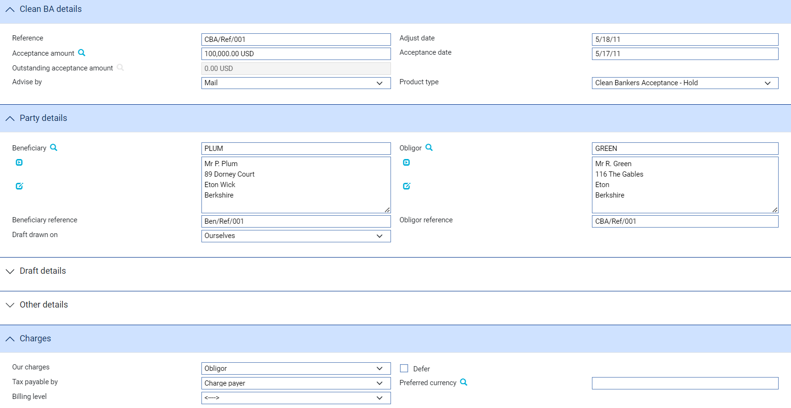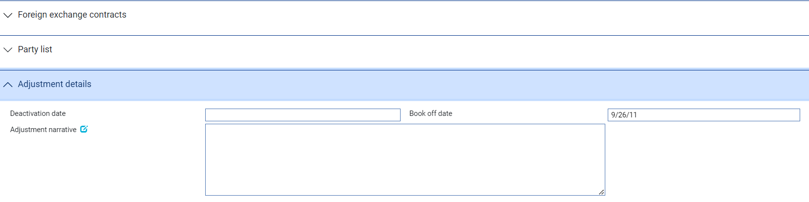

The system displays information already entered for the acceptance during the Create event. Some additional fields are displayed.

The following table explains what to enter into them:

|  |  |  |
| --- | --- | --- |
|  | Field | What to Enter |
|  | Adjust Date | The date of the adjustment. |
|  | Deactivation Date | The system displays the date on which the acceptance will become inactive (after its expiry date and any days grace period has elapsed). You can amend this date, but it must be later than today. |
|  | Book Off Date | The system displays the acceptance's book-off date, which you can amend. The system will then book off the acceptance when the new book-off date is reached. |
|  | Adjustment Narrative | Identify the changes made and the reasons they were made. |